**### Step 1: Ensure/Double Check Permissions on Sensitive Files**

1. Permissions on `/etc/shadow` should allow only `root` read and write access.

- Command to inspect permissions: ls -lah /etc/shadow

- Command to set permissions (if needed): sudo chmod 600 /etc/shadow

2. Permissions on `/etc/gshadow` should allow only `root` read and write access.

- Command to inspect permissions: ls -lah /etc/gshadow

- Command to set permissions (if needed): sudo chmod 600 /etc/gshadow

3. Permissions on `/etc/group` should allow `root` read and write access, and allow everyone else read access only.

- Command to inspect permissions: ls- lah /etc/group

- Command to set permissions (if needed): sudo chmod 644 /etc/group

4. Permissions on `/etc/passwd` should allow `root` read and write access, and allow everyone else read access only.

- Command to inspect permissions:ls -lah /etc/passwd

- Command to set permissions (if needed): sudo chmod 644 /etc/group

**### Step 2: Create User Accounts**

1. Add user accounts for `sam`, `joe`, `amy`, `sara`, and `admin`.

- Command to add each user account (include all five users):

sudo adduser sam #password"987654"

sudo adduser joe #password"123654"

sudo adduser amy #password"asdfgh"

sudo adduser sara #password"football"

sudo adduser admin #password"password"

2. Ensure that only the `admin` has general sudo access.

- Command to add `admin` to the `sudo` group: sudo usermod -aG sudo admin

**### Step 3: Create User Group and Collaborative Folder**

1. Add an `engineers` group to the system.

- Command to add group: sudo addgroup engineers

2. Add users `sam`, `joe`, `amy`, and `sara` to the managed group.

- Command to add users to `engineers` group (include all four users):

sudo usermod -aG engineers sam

sudo usermod -aG engineers joe

sudo usermod -aG engineers amy

sudo usermod -aG engineers sara

3. Create a shared folder for this group at `/home/engineers`.

- Command to create the shared folder: sudo mkdir engineers /home

4. Change ownership on the new engineers' shared folder to the `engineers` group.

- Command to change ownership of engineer's shared folder to engineer group:

sudo chown :engineers /home/engineers | sudo chmod 770 /home/engineers

**### Step 4: Lynis Auditing**

1. Command to install Lynis:

sudo apt -y install Lynis

2. Command to see documentation and instructions:

man Lynis

3. Command to run an audit:

sudo lynis audit <type>

4. Provide a report from the Lynis output on what can be done to harden the system.

- Screenshot of report output:

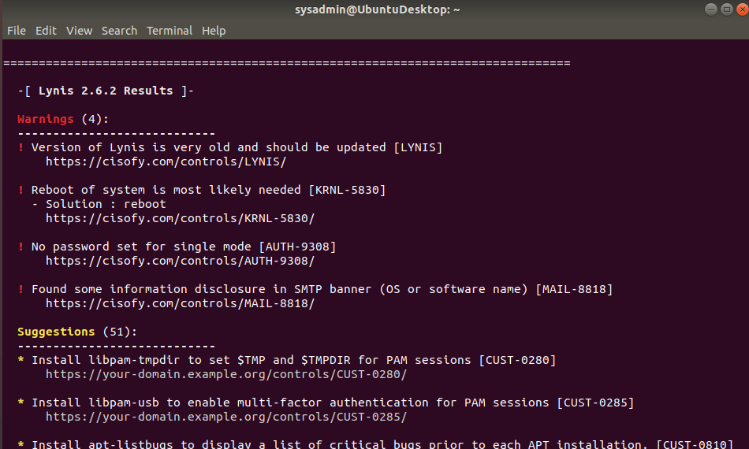

**### Bonus**

1. Command to install chkrootkit:

sudo apt -y install chkrootkit

2. Command to see documentation and instructions:

man chkrootkit

3. Command to run expert mode:

sudo chkrootkit -x

4. Provide a report from the chrootkit output on what can be done to harden the system.

- Screenshot of end of sample output:

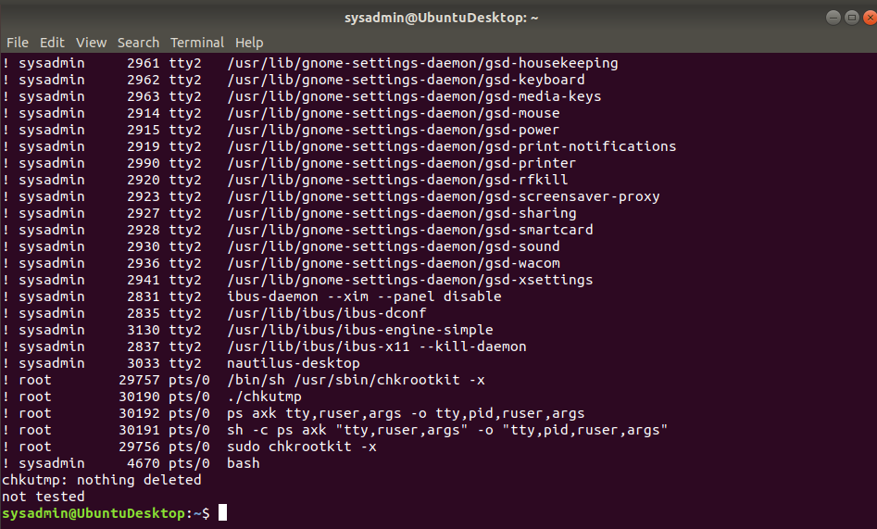

---

© 2020 Trilogy Education Services, a 2U, Inc. brand. All Rights Reserved.